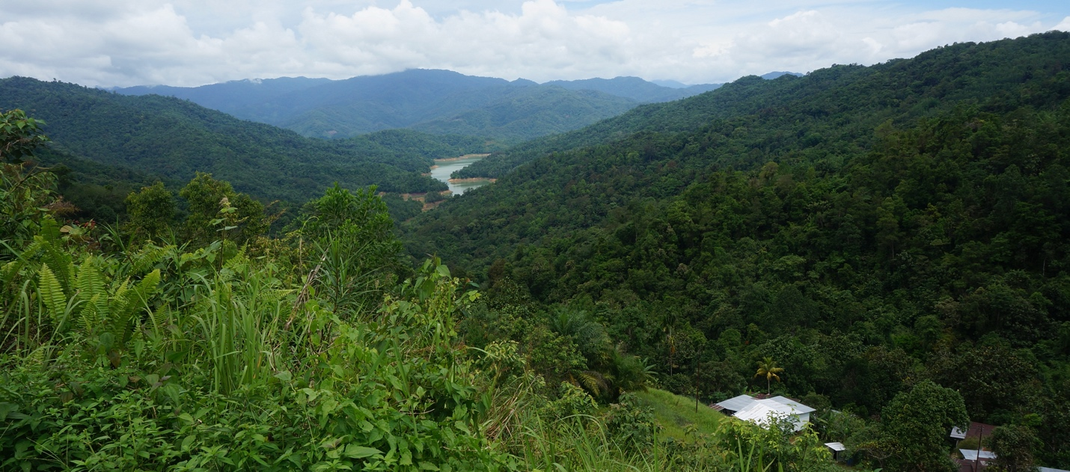

Announcing a four-year PhD graduate fellowship at Oregon State University for 2022:
Community forestry in Southeast Asia

The Forests, Livelihoods, Institutions, and Governance (FoLIAGe - http://foliage.forestry.oregonstate.edu/research) research group, housed in the Department of Forest Ecosystems and Society (FES) in the College of Forestry at Oregon State University in Corvallis, Oregon has a funded position available for a new graduate student Fellow, beginning January, June or September 2022. The Fellowship will support one PhD student for four years interested in conducting research on community forestry in Southeast Asia. The Fellow will work with an interdisciplinary team of researchers located in Corvallis and Bangkok to better understand the institutional arrangements that lead to improved forest condition and livelihoods in Cambodia, Vietnam, and Laos.

The PhD student advertised in this call will work with Dr. Reem Hajjar. The group works in internationally to study the relationship between forests and livelihoods, and how various governance mechanisms and institutions, including policies, laws, norms, and markets, shape that relationship. Much of the group’s research focuses on community and collaborative forestry, impacts of forest governance mechanisms on landscapes and livelihoods, and the links between forests and poverty alleviation.

This PhD student, focusing on community forestry in Southeast Asia, will be part of an interdisciplinary, NSF-funded research project that involves partners across OSU, at the Spatial Informatics Group, and at RECOFTC - The Centre for People and Forests. The PhD student will be responsible for conducting original and publishable research within the context and scope of the larger NSF-funded project. The PhD student will be expected to:
- Complete the FES PhD program in a timely manner (approximately 4 years), including coursework, dissertation proposal, qualification exams and final defense.
- Conduct fieldwork on community forests in Cambodia and work collaboratively with project partners on the ground.
- Contribute substantially to the larger project, including by participating in project meetings, engaging with other project researchers and across disciplines, and contributing to project modeling exercises, publications, and outreach.
- Lead 2-3 journal publications, based on their PhD work.

Funding for the position will cover tuition, fees, and stipend for 4 years for the PhD student (including some terms with teaching responsibilities), as well as travel and research costs.

We encourage applicants from all backgrounds to apply, particularly students who are underrepresented in the field of natural resources management, and particularly from students from Cambodia, Vietnam, Laos, or the broader region (or with strong ties to this region). Experience working with forest-reliant communities in the region would bring great value to this position, as would familiarity with community forest governance and related institutions.

For more information or to express interest in this position, please contact:
Dr. Reem Hajjar: reem.hajjar@oregonstate.edu

Interested applicants should submit a CV and an email describing their interests and experiences with the topic and region, their goals, and also outlining how they meet the required and desirable qualifications outlined below. Promising candidates will be invited to submit a full application, and the successful applicant will be invited to apply to the FES graduate program. Please do not apply to the FES program without this invitation.

Required qualifications
- Excellent writing and oral communication skills
- Research experience or work/life experience related to natural resource governance
- Strong interest in meaningfully engaging with community-based stakeholders throughout the research period
- Ability to work effectively in teams in the office and in the field
- Desire to integrate different disciplines in research on community forest governance
- Master’s degree in related field

Preferred qualifications for PhD position
- Experience working in rural locations in Cambodia and/or neighbouring countries
- Experience working collaboratively on projects
- Experience utilising qualitative and/or quantitative social science research methods
- Experience working on interdisciplinary or multi-disciplinary projects
- Basic knowledge of GIS, statistical, and/or qualitative analysis software

To learn more about the FES Graduate program, please see: https://fes.forestry.oregonstate.edu/graduate-programs/forest-ecosystems-society

